Truncated Hexagonal Pyramid

Definition
# Source: AI Source: Provided by: [Data Path: Persons Table -> ID Column: 1, Name_En Column: Motasem Essam] -> From: [ChatGPT] on [7/25/2026]
A Truncated Hexagonal Pyramid is a solid formed by cutting off the apex of a hexagonal pyramid using a plane parallel to its hexagonal base.
The resulting solid is called a Hexagonal Pyramid Frustum or Frustum of a Hexagonal Pyramid.
It consists of two parallel hexagonal bases of different sizes, connected by six trapezoidal lateral faces.
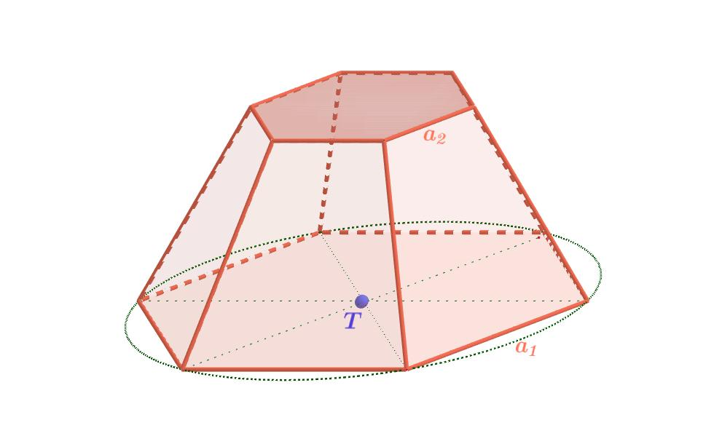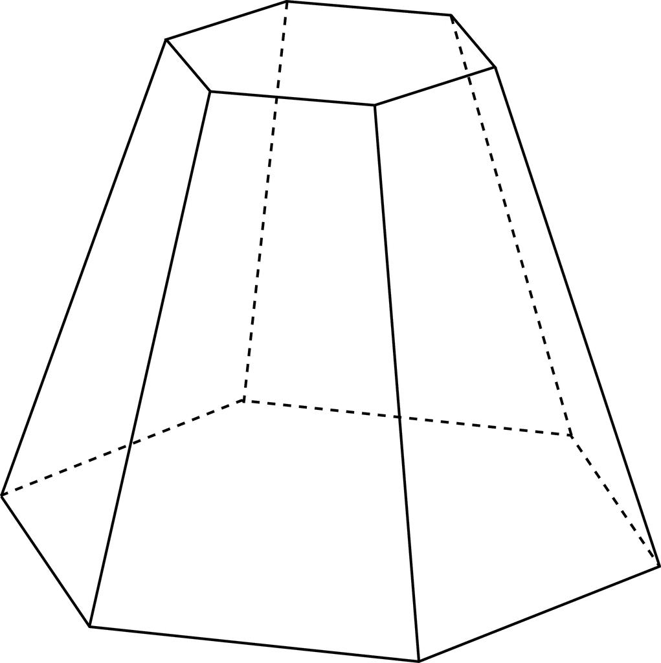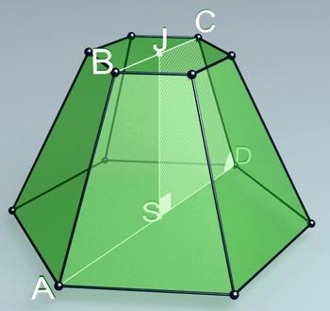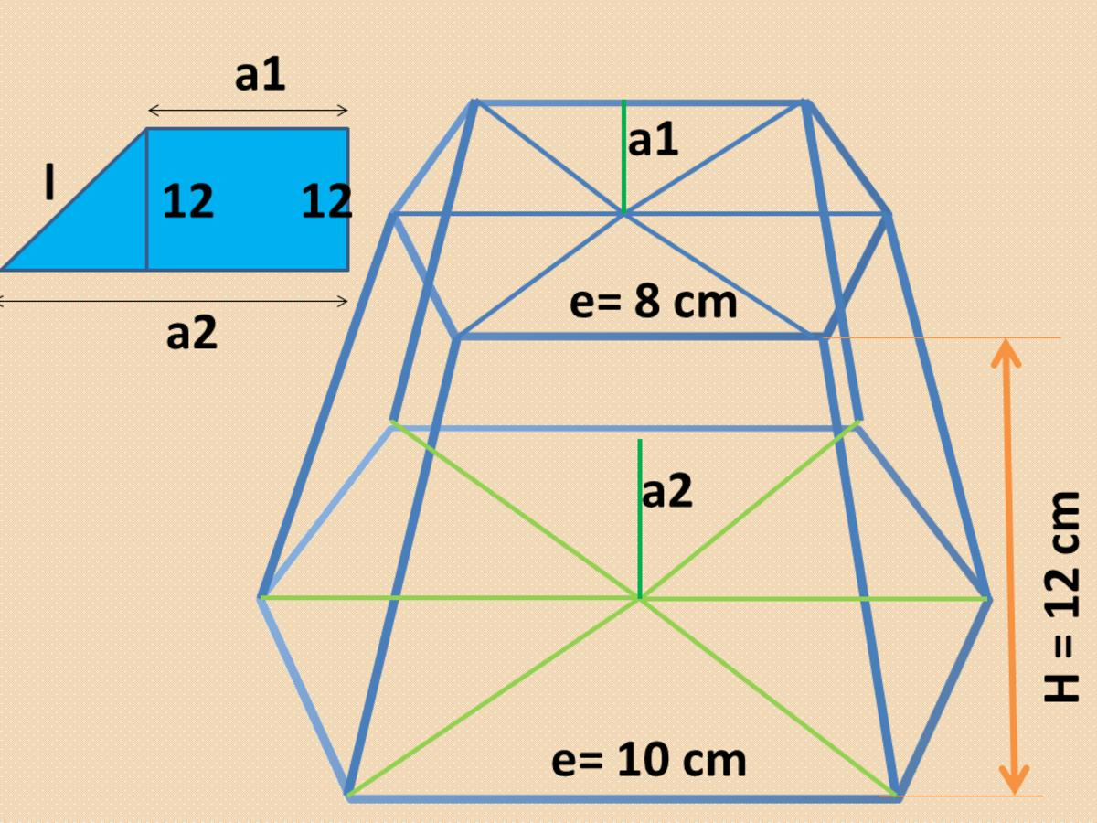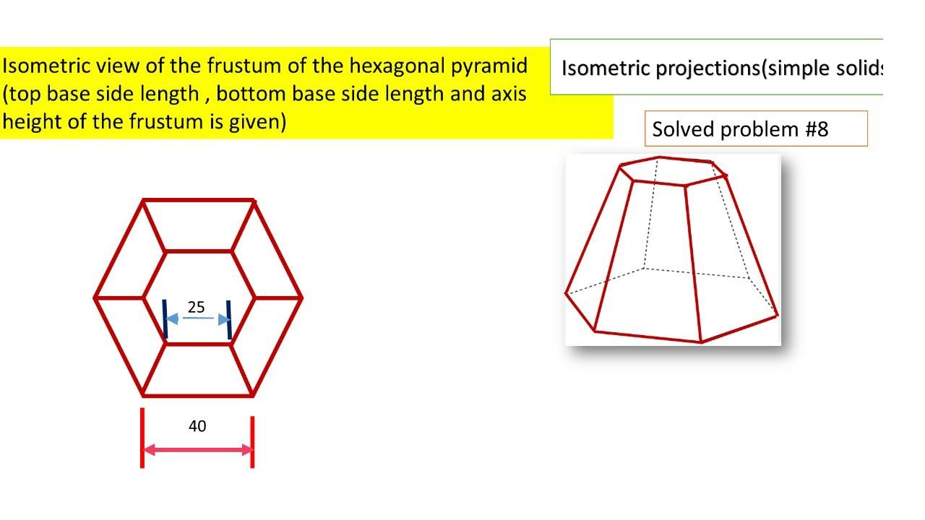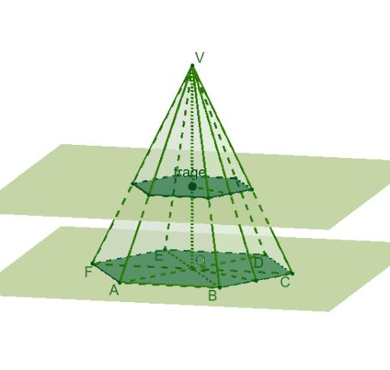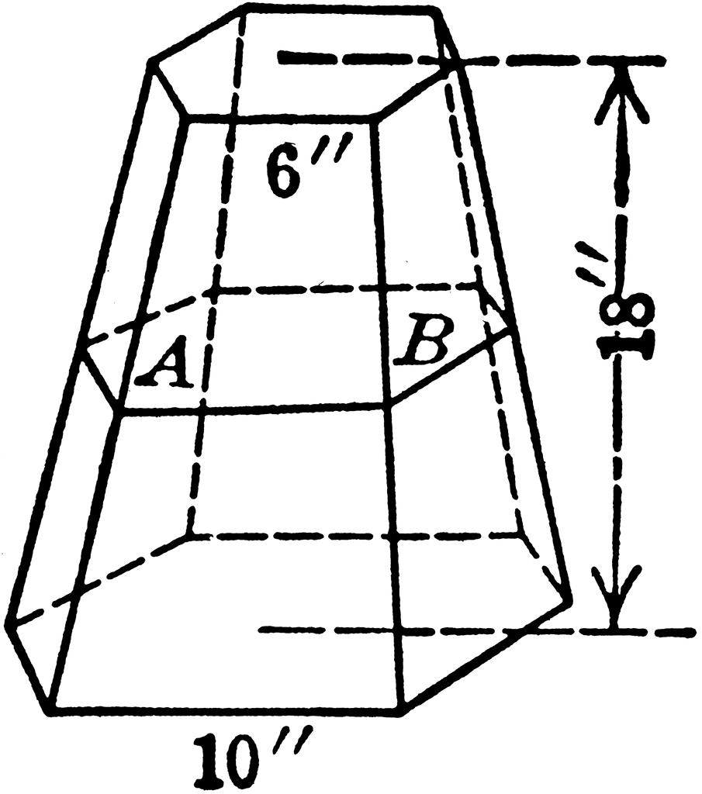

Geometric Structure
# Source: AI Source: Provided by: [Data Path: Persons Table -> ID Column: 1, Name_En Column: Motasem Essam] -> From: [ChatGPT] on [7/25/2026]
An original hexagonal pyramid consists of:
- 1 Hexagonal Base: The bottom face.
- 6 Triangular Lateral Faces: Meeting at the apex.
- 7 Vertices: Six base vertices and one apex.
- 12 Edges: Six base edges and six lateral edges.
After truncation:
- The original hexagonal base remains unchanged.
- A smaller hexagonal face is created by the cutting plane.
- The six original triangular lateral faces become trapezoidal faces.
- The original apex is removed.

Face Composition
# Source: AI Source: Provided by: [Data Path: Persons Table -> ID Column: 1, Name_En Column: Motasem Essam] -> From: [ChatGPT] on [7/25/2026]

Large Hexagonal Base
# Source: AI Source: Provided by: [Data Path: Persons Table -> ID Column: 1, Name_En Column: Motasem Essam] -> From: [ChatGPT] on [7/25/2026]
The original base of the hexagonal pyramid.

Small Hexagonal Base
# Source: AI Source: Provided by: [Data Path: Persons Table -> ID Column: 1, Name_En Column: Motasem Essam] -> From: [ChatGPT] on [7/25/2026]
The new face created by the cutting plane parallel to the original base.
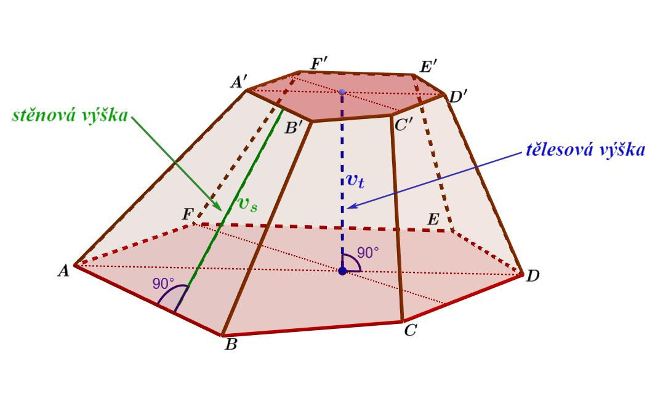

Trapezoidal Lateral Faces
# Source: AI Source: Provided by: [Data Path: Persons Table -> ID Column: 1, Name_En Column: Motasem Essam] -> From: [ChatGPT] on [7/25/2026]
The remaining portions of the original triangular lateral faces.
Total face composition:
- 2 Hexagonal Faces.
- 6 Trapezoidal Faces.
- 8 Faces in total.

Mathematical Properties
# Source: AI Source: Provided by: [Data Path: Persons Table -> ID Column: 1, Name_En Column: Motasem Essam] -> From: [ChatGPT] on [7/25/2026]
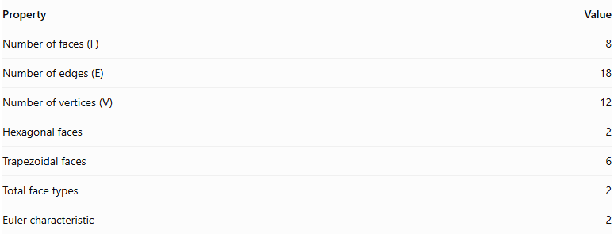
Property | Value
Number of faces (F) | 8
Number of edges (E) | 18
Number of vertices (V) | 12
Hexagonal faces | 2
Trapezoidal faces | 6
Total face types | 2
Euler characteristic | 2
Euler's Formula
$$V-E+F=2$$
$$12-18+8=2$$
Volume Formula
$$V=\frac{h}{3}(A_{1}+A_{2}+\sqrt{A_{1}A_{2}})$$
Where:
- $h$ = perpendicular distance between the two hexagonal bases.
- $A_{1}$ = area of the larger hexagonal base.
- $A_{2}$ = area of the smaller hexagonal base.
For regular hexagonal bases with side lengths $a$ and $b$:
$$A_{1}=\frac{3\sqrt{3}}{2}a^{2}$$
$$A_{2}=\frac{3\sqrt{3}}{2}b^{2}$$
Therefore:
$$\boxed{V=\frac{\sqrt{3}h}{2}(a^{2}+ab+b^{2})}$$

Constructing Truncated Hexagonal Pyramid in Solid Geometry

Instruments Used
# Source: AI Source: Provided by: [Data Path: Persons Table -> ID Column: 1, Name_En Column: Motasem Essam] -> From: [ChatGPT] on [7/25/2026]
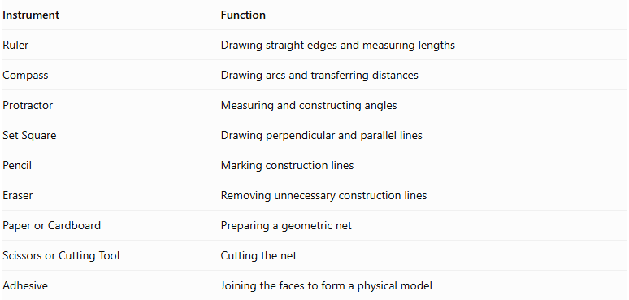
Instrument | Function
Ruler | Drawing straight edges and measuring lengths
Compass | Drawing arcs and transferring distances
Protractor | Measuring and constructing angles
Set Square | Drawing perpendicular and parallel lines
Pencil | Marking construction lines
Eraser | Removing unnecessary construction lines
Paper or Cardboard | Preparing a geometric net
Scissors or Cutting Tool | Cutting the net
Adhesive | Joining the faces to form a physical model

Construction Procedures

A. Original-Pyramid-Based Construction
# Source: AI Source: Provided by: [Data Path: Persons Table -> ID Column: 1, Name_En Column: Motasem Essam] -> From: [ChatGPT] on [7/25/2026]
- Draw a hexagonal base.
- Construct the original hexagonal pyramid by locating its apex.
- Draw a cutting plane parallel to the hexagonal base.
- Mark the intersections of the cutting plane with the six lateral edges.
- Remove the smaller upper portion conceptually or physically.
- Connect the intersection points to form the smaller hexagonal base.
- Darken the visible edges of the truncated solid.

B. Base-Based Construction
# Source: AI Source: Provided by: [Data Path: Persons Table -> ID Column: 1, Name_En Column: Motasem Essam] -> From: [ChatGPT] on [7/25/2026]
- Draw the larger hexagonal base.
- Draw a smaller similar hexagon above it.
- Ensure that the two bases are parallel.
- Match corresponding vertices.
- Connect the corresponding vertices using straight lines.
- Complete the six trapezoidal lateral faces.

C. Vertex-Connection Construction
# Source: AI Source: Provided by: [Data Path: Persons Table -> ID Column: 1, Name_En Column: Motasem Essam] -> From: [ChatGPT] on [7/25/2026]
- Identify the six vertices of the lower hexagon.
- Identify the six corresponding vertices of the upper hexagon.
- Connect each pair of corresponding vertices.
- Complete the lateral edges.
- Distinguish visible edges from hidden edges.

D. Edge-Based Construction
# Source: AI Source: Provided by: [Data Path: Persons Table -> ID Column: 1, Name_En Column: Motasem Essam] -> From: [ChatGPT] on [7/25/2026]
- Draw the six edges of the lower hexagonal base.
- Draw the six edges of the upper hexagonal base.
- Connect corresponding endpoints.
- Complete the eighteen edges of the solid.

E. Face-Based Construction
# Source: AI Source: Provided by: [Data Path: Persons Table -> ID Column: 1, Name_En Column: Motasem Essam] -> From: [ChatGPT] on [7/25/2026]
- Construct the lower hexagonal base.
- Construct the upper hexagonal base.
- Draw six trapezoidal lateral faces.
- Join the lateral faces to the two bases.

F. Net-Based Construction
# Source: AI Source: Provided by: [Data Path: Persons Table -> ID Column: 1, Name_En Column: Motasem Essam] -> From: [ChatGPT] on [7/25/2026]
- Draw one large hexagon.
- Draw one smaller similar hexagon.
- Construct six trapezoids around the larger hexagon.
- Add suitable joining tabs if preparing a physical model.
- Cut out the net.
- Fold the six trapezoids upward.
- Attach the smaller hexagon to the upper edges.
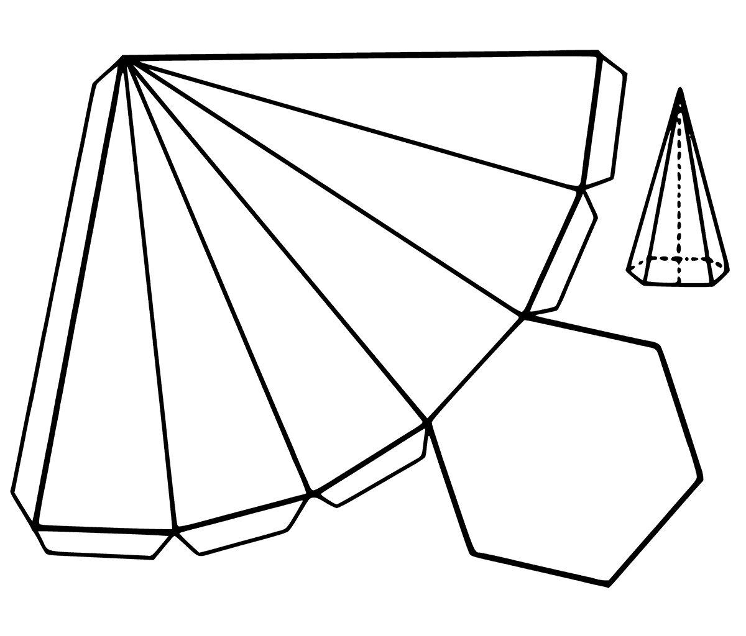

Key Points
# Source: AI Source: Provided by: [Data Path: Persons Table -> ID Column: 1, Name_En Column: Motasem Essam] -> From: [ChatGPT] on [7/25/2026]
- It originates from a hexagonal pyramid.
- It is formed by removing the apex using a plane parallel to the base.
- It has two parallel hexagonal bases of different sizes.
- It has six trapezoidal lateral faces.
- It contains 8 faces, 18 edges, and 12 vertices.
- It is classified as a hexagonal pyramid frustum.
- Its volume depends on the height and areas of its two bases.
Important distinction:
A Hexagonal Pyramid Frustum should not be confused with a Vertex-Truncated Hexagonal Pyramid, in which vertices are cut off individually rather than removing the apex with a plane parallel to the original base.

Conclusion
# Source: AI Source: Provided by: [Data Path: Persons Table -> ID Column: 1, Name_En Column: Motasem Essam] -> From: [ChatGPT] on [7/25/2026]
The Truncated Hexagonal Pyramid is a hexagonal pyramid with its apex removed by a plane parallel to its base. It forms a hexagonal pyramid frustum consisting of two hexagonal bases and six trapezoidal lateral faces, with 8 faces, 18 edges, and 12 vertices.

